Justice Loretta H. Rush
(One hundred eighth Justice)
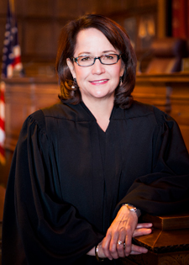
High-Resolution
Loretta H. Rush was appointed to the Indiana Supreme Court by Governor Mitch Daniels in September 2012. Born in 1958 in Pennsylvania, she moved frequently as a child before settling in Lafayette for her adult life. Rush earned her undergraduate degree from Purdue University and graduated cum laude from the Indiana University Maurer School of Law in Bloomington.
Prior to her appointment to the Indiana Supreme Court, Justice Rush served as Tippecanoe Superior Court 3 judge for 14 years. The court focuses on CHINS, criminal and status offenses of juvenile cases, guardianships, delinquencies and protective order hearings. She assisted with the creation of the Tippecanoe County Court Appointed Special Advocate (CASA) program.
Prior to being elected judge, she spent 15 years in general practice as an associate and then partner at a Lafayette firm. Her practice consisted of civil litigation, family law, business, personal injury, corporate, probate and workers compensation cases.
Justice Rush serves as the liaison to the Judicial Conference Juvenile Justice Improvement Committee, Judicial Conference Problem-Solving Courts Committee and State Board of Law Examiners. She is the Chair of the Commission on Improving the Status of Children in Indiana and the Indiana Conference for Legal Education Opportunity. Rush has served as the chair of the Indiana Juvenile Justice Improvement Committee which involves statutory and regulatory efforts to bring better and standardized child welfare practice to Indiana. She was chair of the Indiana Court Improvement Program Executive Committee and Child Welfare Improvement Committee, served on the Indiana Supreme Court Judicial Technology and Automation Committee and was president of the Indiana Council of Juvenile and Family Court Judges. She also serves on the National Council of Juvenile and Family Court Judges and was appointed to the National Judicial Leadership Summit on the Protection of Children.
Justice Rush is a member of the Tippecanoe, Indiana and American Bar Associations, Indianapolis American Inn of Court and Indiana and National Council of Juvenile and Family Court Judges. In 2003 she was honored to receive the Kinsey Award for Juvenile Judge of the Year and in 2001 was presented with the Fiscal Responsibility Award by the Tippecanoe County Council and Commissioners.
She is married with four children.

